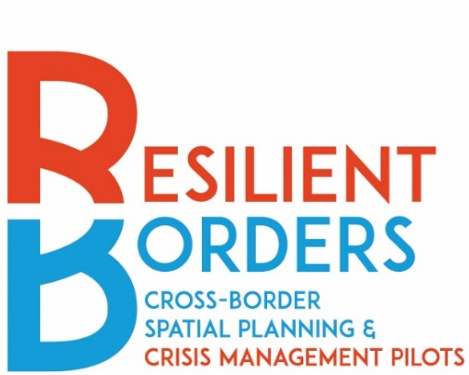
10/2024
RESILIENT BORDERS
CONTENT
OF THE ONLINE APPLICATION FORM
Cross-Border Spatial Planning and Crisis Management Pilot Actions

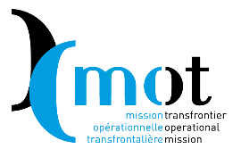

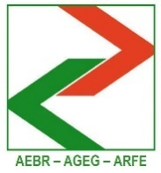

CONTENT OF THE ONLINE APPLICATION FORM (FOR INFORMATION ONLY)
APPLICATION TO BE SUBMITTED ONLINE

Managed by the Association of European Border Regions (AEBR) and Mission Opérationnelle Transfrontalière (MOT) through an Action Grant (2022CE160AT316 CB-CRII) agreed with the Directorate General of Regional and Urban Policy, European Commission.
Co-financed by the European Union, AEBR and MOT.

Published on resilientborders.eu on 4 October 2024

Application Form
Fields marked with an * are required

Applicants’ organisation

Type of organisation *

Select the type of organisation you represent or apply for.
Ο Local authority
Ο Regional authority
Ο National authority
Ο EGTC
Ο Euroregion and similar cross-border structures with legal personality

Is your organisation based in one of the 27 EU countries or one of the EFTA countries? * Ο Yes Ο No
Is the applicant organisation a public body? * Ο Yes Ο No
Is the applicant organisation a cross-border structure? * Ο Yes Ο No

Name of the applicant organisation *
Write the full name of the organisation you represent or apply for, in local language and English.
……………..
Address of the applicant *
……………..
Main contact person
Last name * ……………..
First name * ……………..
E-mail * ……………..
Phone * ……………..
Backup contact person
Last name * ……………..
First name * ……………..
E-mail * ……………..
Phone * ……………..

Partner organisation in the neighbouring country of the main applicant
Please note that having one partner is essential for public bodies. However, having a partner is not mandatory for cross-border structures with legal personality.
Type of organisation
Select the type of organisation of you partner organisation.

Ο Local authority
Ο Regional authority
Ο National authority
Ο EGTC
Ο Euroregions and similar cross-border structures with legal personality

Is your organisation based in one of the 27 EU countries or one of the EFTA countries?
Ο Yes Ο No
Is the partner organisation a public body?
Ο Yes Ο No
Is the partner organisation a cross-border structure?
Ο Yes Ο No
Name of the applicant organisation
Write the full name of the partner organisation, in local language and English
……………..
Address of the partner organisation
……………..
Main contact person
Last name ……………..
First name ……………..
E - mail ……………..
Phone ……………..
Backup contact person
Last name ……………..
First name ……………..
E-mail ……………..
Phone ……………..
Partner declaration(s)
Should you apply with one or more partners, please upload here the partner declaration(s) completed and signed by the partner(s)
Please note that only PDF files can be uploaded (see template). The file should have this format: PDF.
Select Files

……………..
Should you want to add more partners, please click here to fill out information on additional partners:

Add more partners 1:
Type of organisation
Select the type of organisation
Ο Local authority
Ο Regional authority
Ο National authority
Ο EGTC
Ο Euroregion or similar cross-border structure with legal personality
Is the partner organisation a public body?
Ο Yes
Ο No
Is the partner organisation a cross-border structure?
Ο Yes
Ο No
Name of the partner organisation
Write the full name of the organisation you represent or apply for, in local language and English.
……………..
Address of the partner organisation
……………..
Main contact person
Last name ……………..
First name ……………..
E-mail ……………..
Phone ……………..
Back-up contact person
Last name ……………..
First name ……………..
E-mail ……………..
Phone ……………..
Add partners File

Your pilot action

1. Title of the proposed pilot action *
Please indicate a title for the pilot action. Please limit to 10 words.

……………..

2. Border area concerned by the pilot action *
Please indicate what territory will benefit from the pilot action. Please limit to 50 words.

……………..
3. What is the nature of the partnership? *

Please choose the option that best describes the nature of the partnership between you and your partner.
Ο This cross-border partnership is a new initiative

Ο This cross-border partnership is a continuation of a previous project/initiative

Ο This cross-border partnership builds on a long-standing partnership

Ο This cross-border partnership is already institutional (for example, cross-border structures with legal personality)

4. What lot does the application address? *

Ο Cross-border Crisis Management

Ο Cross-border Spatial Planning

5. What does your pilot action aim to develop? *
Ο Agreements (under Crisis Management)

Ο Institutions (under Crisis Management)

Ο Tools (under Crisis Management)

Ο Processes (under Crisis Management)

Ο Cross-border governance bodies (under Spatial Planning)

Ο Internal governance and stakeholder participation (structures) (under Spatial Planning)

Ο Strategic planning documents (under Spatial Planning)

Ο Information sharing (under Spatial Planning)

Ο Cross-border public services (under Spatial Planning)

Ο Monitoring and evaluation of cross-border governance (under Spatial Planning)

Ο Sustainable and adaptable funding (under Spatial Planning)

Ο Durable political commitment (under Spatial Planning)

Ο Visibility and promotion of the cross-border region (under Spatial Planning)

6. Specific objective of the Pilot Action *
Please outline the specific objectives that the pilot action will aim to achieve.
Please limit to 500 words.
……………..
7. Methodology and action plan to achieve the above objectives
Please describe the methodology, including a list of actions that will be organised to achieve the objective of the pilot action. Please limit to 1,000 words.
……………..
8. Calendar of activities of the pilot action *
Please outline a preliminary calendar of the activities to be organised in the framework of the pilot action.
Please note that only Excel files or PDF can be uploaded (see templates). The file should have one of these formats: XLS, XLSX, XLSM, XML, PDF.
Select File
……………..
9. Budget of the pilot action *
Please upload a preliminary budget necessary to develop the pilot action, including justification of costs (see eligible expenditures hereafter*)
Please note that only Excel files or PDF can be uploaded (see templates). The file should have one of these formats: XLS, XLSX, XLSM, XML, PDF.
Select File

……………..

Criteria for Selection

1 Relevance
Relevance 1.1 - How does the action contribute to achieve the resilience of the cross-border region? *
Please limit to 160 words.
……………..
Relevance 1.2 - What factors guarantee the success of your action plan? *
Please limit to 160 words.
……………..
Relevance 1.3 - How does your pilot action contribute to increase knowledge and skills development for relevant stakeholders? *
Please limit to 160 words.
……………..
Relevance 1.4 - How do you plan to involve relevant stakeholders with clear mandate to move forward on a stronger
cooperation? *
Please limit to 160 words.
……………..
Relevance 1.5 - Is your pilot action a follow up to previous Interreg projects or other initiatives in the same field? How do you plan to capitalise on previous experiences? Or is your pilot action a (new) solution to a lack of cooperation? *
Please limit to 160 words.
……………..

2 Cross-border added value
Cross-border added value 2.1 What dimensions of cross-border cooperation does the pilot action address?
Please select at least 2 options from this list.
To select, click on the preferred option. To make multiple selections, press CMD+click (on Mac) or CTRL+click (on Windows).
Ο Economy: create conditions for a win-win economic development of the cross-border region, including public funding of necessary investments
Ο Functionality: develop cross-border public services
Ο Institutionality: develop a cross-border governance able to coordinate public policies for citizens living there
Ο Information: develop cross-border-shared data and information
Ο Culture and people-to-people: develop a cross-border sense of belonging, vision for the future, and cross-border networks of persons
Ο Environment: contribute to ecological transition and/or climate adaptation beyond borders
Cross-border added value 2.2 How does the pilot action address the selected dimensions of cross-border cooperation? *
Please limit to 160 words.
……………..

3 Impact
Impact 3.1 - What is the expected long-term impact of results on target groups or the general public? *
Please limit to 160 words.
……………..

Impact 3.2 - Do you think that the results could be replicated in other border areas? Are you willing to share your experience with other regions in the future? *
Please limit to 160 words.
……………..
Impact 3.3 - What is the sustainability of your action’s results after funding ends? *
Please limit to 160 words.
……………..

Background Information

Additional information

Upload any additional information you may find useful (strategies, projects deliverables, studies, etc.).
Select Files

……………..

Data Use and Terms & Conditions
Confirmation of data use and conditions to apply *
Please confirm the following options
Ο I have read and understood the preconditions of economic behaviour outlines in the call for proposals
Ο I have read and understood the obligations of the awarded beneficiaries outlined in the call for proposals
Ο I confirm that this application contains original content authored by the applicant organisation.
Ο By submitting this application, I declare that the proposed advice case will not be simultaneously financed by other sources from the EU budget.
Ο I hereby give permission to AEBR, MOT and the European Commission to utilise and publish the information submitted in this application for purposes of communication and research, even if the proposed case is not selected.

Submit

